Social Innovation and sustainable development in Greenland

Transform your wildest idea for social innovation
to a sustainable project with solid funding possibilities

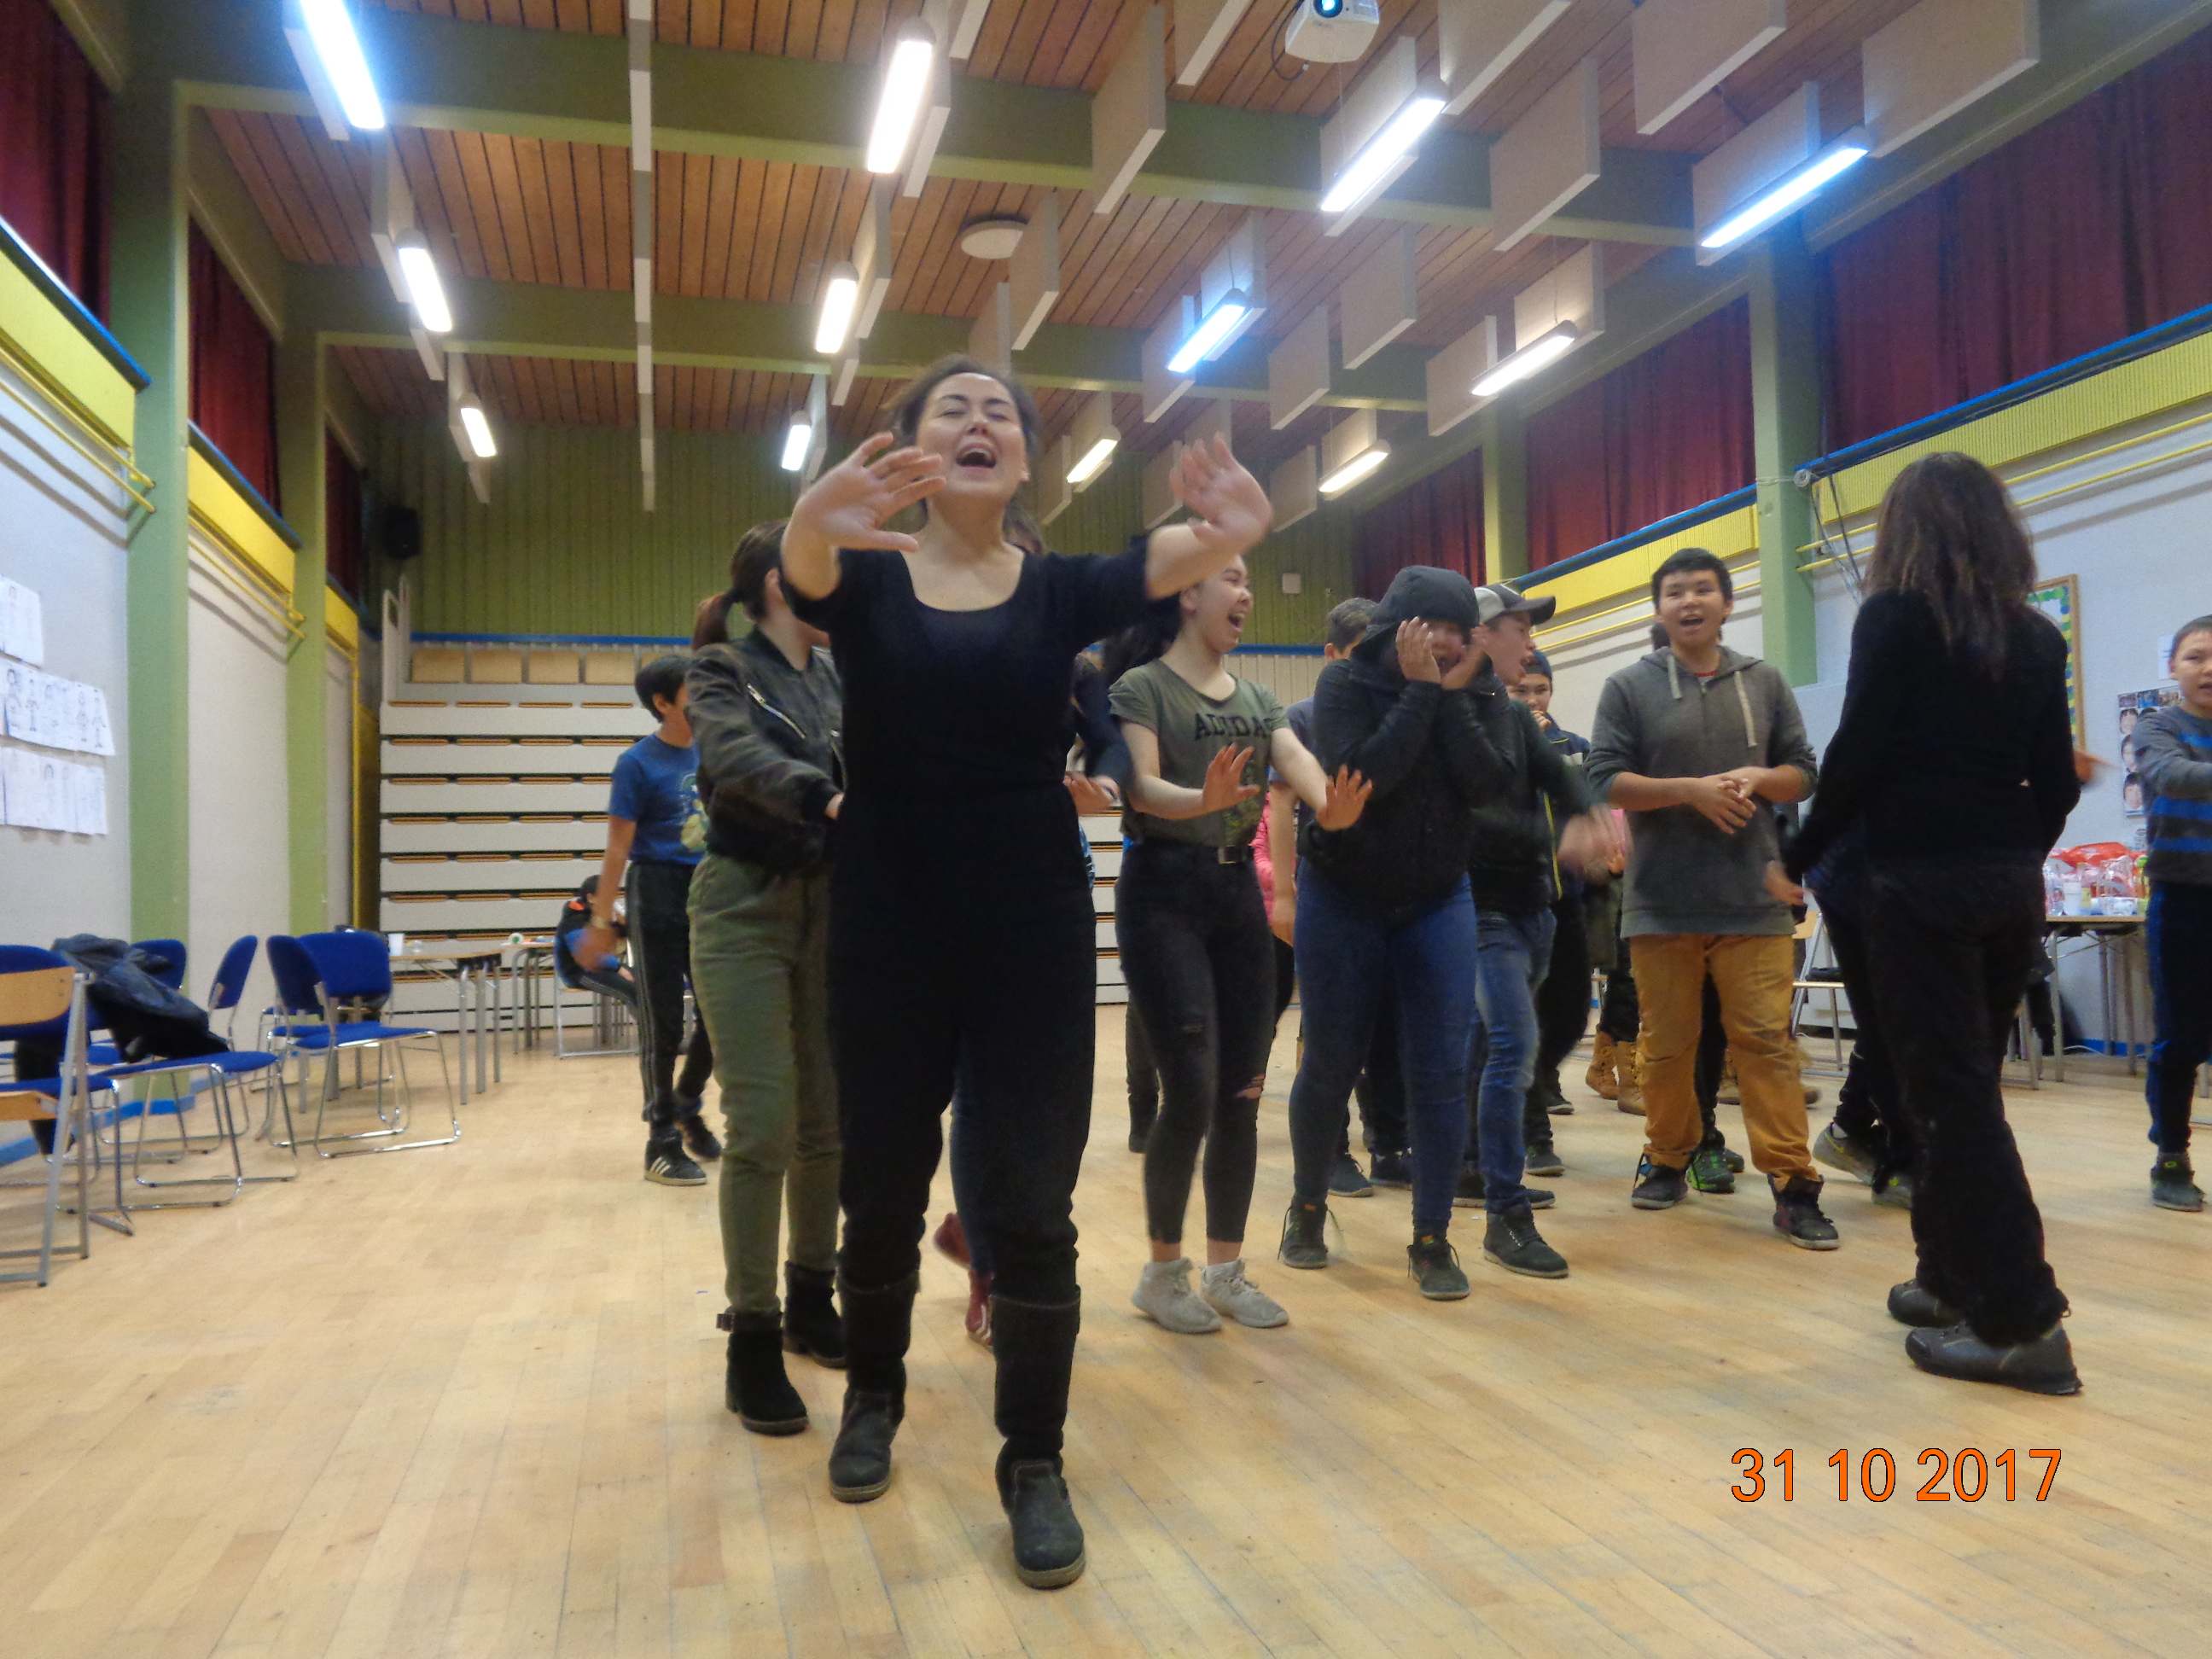

A 3-days workshop on March 5-7th from 9 am-3.30 pm
Open for all students at Ilisimatusarfik/The University of Greenland

Ideation, fundraising and implementation of social projects
The workshop will work with the entire process from ideation to implementation. One important step on this journey is how to finance your project. The workshop will focus on fundraising in various ways. Communicating your project is also key to how you make sure you land it successfully among all stakeholders.

The process is also applicable for social entrepreneurship aiming at generating profit and solving social problems at the same time. This process includes getting the idea, setting the goal and the objectives, formulating indicators, stating the activities, calculating needed resources, investigating the local context, and planning evaluation of results in term of success, efficiency, and sustainability.

In the workshop, you will learn how to write an application, how to submit and how to be flexible in the dialogue with the donor and with the target population. A project document is a working paper in progress but still you have to achieve the goal and the objectives, which are the heart of the program.

There are many donor organizations, which support programs in Greenland. In general, there is a shortage of applications for funding from people – especially young people – in Greenland. One of the reasons for this could be that there is a need for more practical knowledge on how to apply for donor financial support.

The main goal of this workshop is to provide you with the skills for defining a strong social project. It is also to provide you with the skills needed to fundraise in a successful way.
That will be helpful for you – but even more importantly, it will provide highly needed support for people living with social problems, having difficulties getting a formal education or a job even though they hold strong human values of caring, of mutual respect, and of social responsibility.

The workshop facilitators are:
Anette Molbech – Anthropologist and Coordinator of the project Siunissaq uagut pigaarput
Tina Enghoff – Artist, Photographer, and Art Consultant to Siunissaq uagut pigaarput
Niviaq Korneliussen, atuakkiortoq / writer
Peter Berliner, Professor at Dept. of Social Science, Economy, and Journalism, Ilisimatusarfik.

Other valued facilitators of the Siunissaq workshops are:
Augustine Rosing, promotor of sexual rights and community based participatory research methods in Greenland.
Elena de Casas Soberón, sexologist and educator of sexual rights and empowerment of women.
Ulrikka Holm, Sexologist, family counselor, and licensed professional fisher and hunter.
Soeren Hertz, Photographer with a focus on photographers for Human Rights.
And all the treasurable key resource people in Maniitsoq, Nanortalik, and Tasiilaq
And, least but not last, the young people of Maniitsoq, Nanortalik, and Tasiilaq, who are building the future right now.

The workshop builds on lessons learned from practical experience. It is a hands-on workshop. Furthermore, it builds on and contribute to theories of Social Entrepreneurship and Social Innovation.
In the sessions, we will examine, analyse and dialogue upon international theories on social resiliens and community-based social innovation. We will address collective learning and development with a particular focus on how you can solve social problems in ways that create sustainability, income, and self-determination. There will be a particular focus on Maniitsoq and Kangaamiut as communities with a strong emphasis on the unity of social, cultural, ecological, and economic sustainability – as part of the Qeqqata Komunia’s viable policy of sustainable development. This focus opens for synergy through case studies on – and mutual contribution to – the ongoing initiatives in Maniitsoq.
Furthermore, we will present lessons learned from the strong and successful program, Paamiut Asasara as well as best practices in the Siunissaq activities in Tasiilaq and Nanortalik.

Program:

5th March 2018 - From vision to action - how to shape your idea(s) and turn them into a project plan.

9:00 AM – 11:45 AM. Ideation – how to let your ideas grow freely.
- The story about Siunissaq uagut pigaarput – from dreams to action (see: www.Siunissaq.gl)
Presentation of Maniitsoq youth program as part of the overall ecological, economic, social, and cultural sustainability program – inspired by the five principles for the global sustainable development goals: People, planet, Income, partnership, and peace.
- Brainstorming on good ideas, visions, and enthusiasm.
Ideas as balloons, Arctic terns, aerial dancers, human cannonballs or journeying spirits?
- From visions to goals and objectives.
You can look in all directions but you can only start walking in one direction.
- How to describe goal and objectives?
- Starting writing the application for funding.

12:30 PM – 15:00 PM
People, planet and livelihood – how to solve social problems and get funding or generate money through social innovation

- Definition of social challenges.
- Definition of social resources.
- Thinking in processes, systems, and networks.
- Co-writing of background, goals, and objectives.
- Collaborative learning and collective intelligence.
The core of learning together is joy, responsibility, and dialogue.

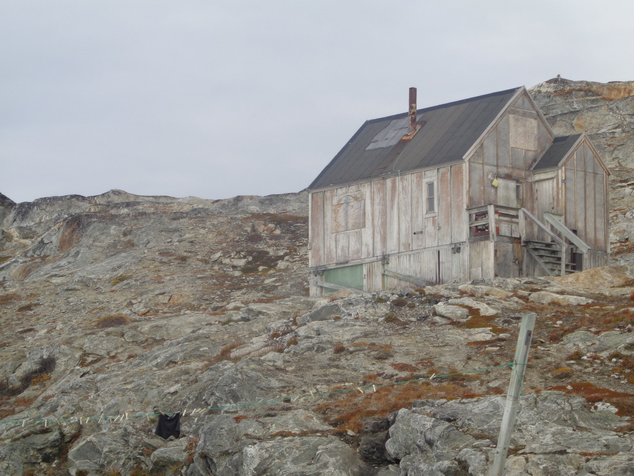
The coming Art and Culture Centre of Didderidar – for visiting artists in need of quietness and contemplation?
From idea to implementation is just a small step for you – but a giant leap for Human Kind.

6th March 2018 - Indicators and activities – the pathway to social innovation.

9:00 AM – 11:45 AM. How to document that we are getting there, i.e. that we achieve our goals and objectives

- Definition of indicators for processes and for results.
Dialogue on indicators of sustainability.
- Baseline – how to know, where we are, before we start walking.
- Indictors, evaluation, and documentation.
- Participatory community-based action research, empowerment, global distribution of knowledge, Indigenous methods, story-telling and solutions-focussed knowledge – the easy trail to joyful research that matters.
- Action writing: Thinking together to make the process of writing flow.
- Applying the methods: Supportive feedback, synergy, and open dialogue.

12:30 PM – 15:00 PM: Activities – what do we do together to make a change?

- What is an activity?
- How do use activities to bridge between goals and indicators of results
- Action learning: the creation of activities here and now.
How to build the aircraft while we are already flying.
- The concepts of process, parallel-processes, and counter-productivity.
Is something actually moving or are we stuck, do we learn, to we enjoy, do we laugh, do we release, do we liberate? – Or are we simply bored?
Are we alive and joyfully kicking?
Are we listening to our heartbeat on the move, letting life unfold?
- Collective co-writing of activities in our projects.

Can you solve a social challenge, build sustainability, and make a business out of the blue?

7th March 2018 - Resources and assumptions.

9:00 AM – 11:45 AM: What we need to implement our project.
- Talking about money.
Is it right that everything has a price? How much does it cost? Can we do it for less? Can we get more funding?
- How to make the budget.
How to let money talk - and dance.
- Distribution of resources, social responsibility, and accountability.
- Different kinds of resources – human, technical, cultural, material.
- Logistics
How to be in one place at a time.
- Making lists of needed inputs.
- Creative and innovative thinking: 100 ways of getting what, we need.
- Dialogue on assumptions, i.e. what we expect to be present in the local community and beyond.
- If our assumptions are inadequate – what do we do, when we already started our journey?
- To go with the flow
To follow unexpected invitations, take reached out hands, find inflection points, engage in eye opening dialogues, positively reformulate adversity, change tracks in the middle of the stream, see the light, to find a way: Piumassuseq isit aqqutaanni ingerlaffigiuminaatsumiippoq

12:30 PM – 15:00 PM: Bringing it all together.

- Different types of donors.
- How to send/upload your application
- Contact, dialogue and negotiations with the donor.
- How to make your application visible and relevant for a donor.
- Follow-up and re-negotiating your project application – learning from the local community and advocate the local knowledge on needs, pathways, goals, and active participation to the donor.
- Options for applications especially for Greenland and the Arctic.
- Sending the written applications for comments in Maniitsoq.
- Planning next step – the submission of the written application to a donor.

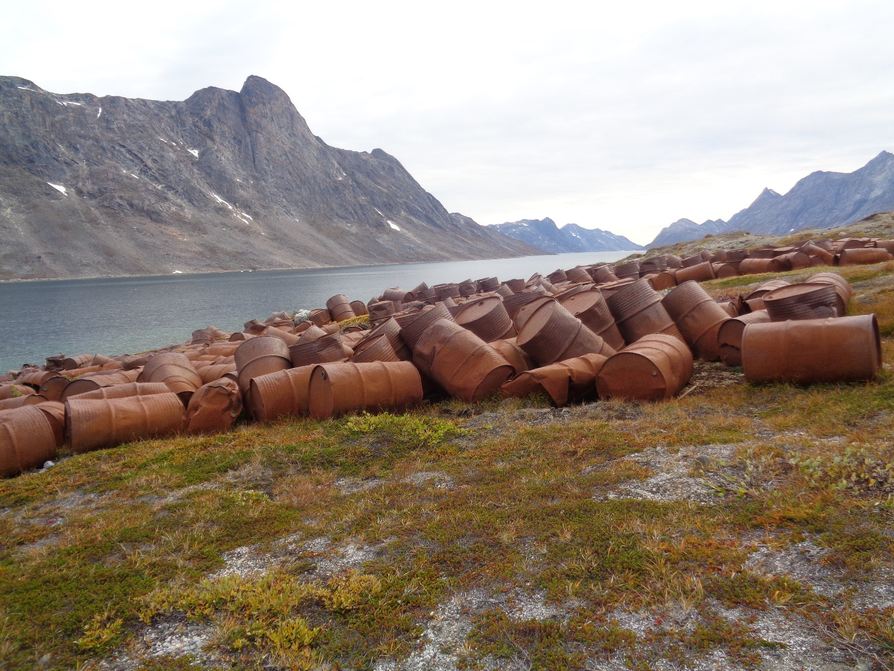
The start of “Ikateq Heartbeat Drumming Men for Protection of Children and Women against Violence”? Get into a shared rhythm, make a big noise and sell drums to all settlements and towns – and be heard all over the world. It is like sex – two adults freely and without coercion joined in a shared rhythm making a lot of joyful noise to express their love, affection and caring.

https://www.qeqqata.gl/Nyheder/2017/06/Solceller?sc_lang=kl-GL
Maniitsumi Paarsi seqinisaatitaarpoq
Maniitsumi meeqqerivik Paarsi seqinisaatilerneqarpoq. Illup siusinnerusukkut altaniini ikkersuutai krydsfineriusut nutaanngitsut, illup nutarterneqarneranut atatillugu seqinisaatinik taarserneqarput.
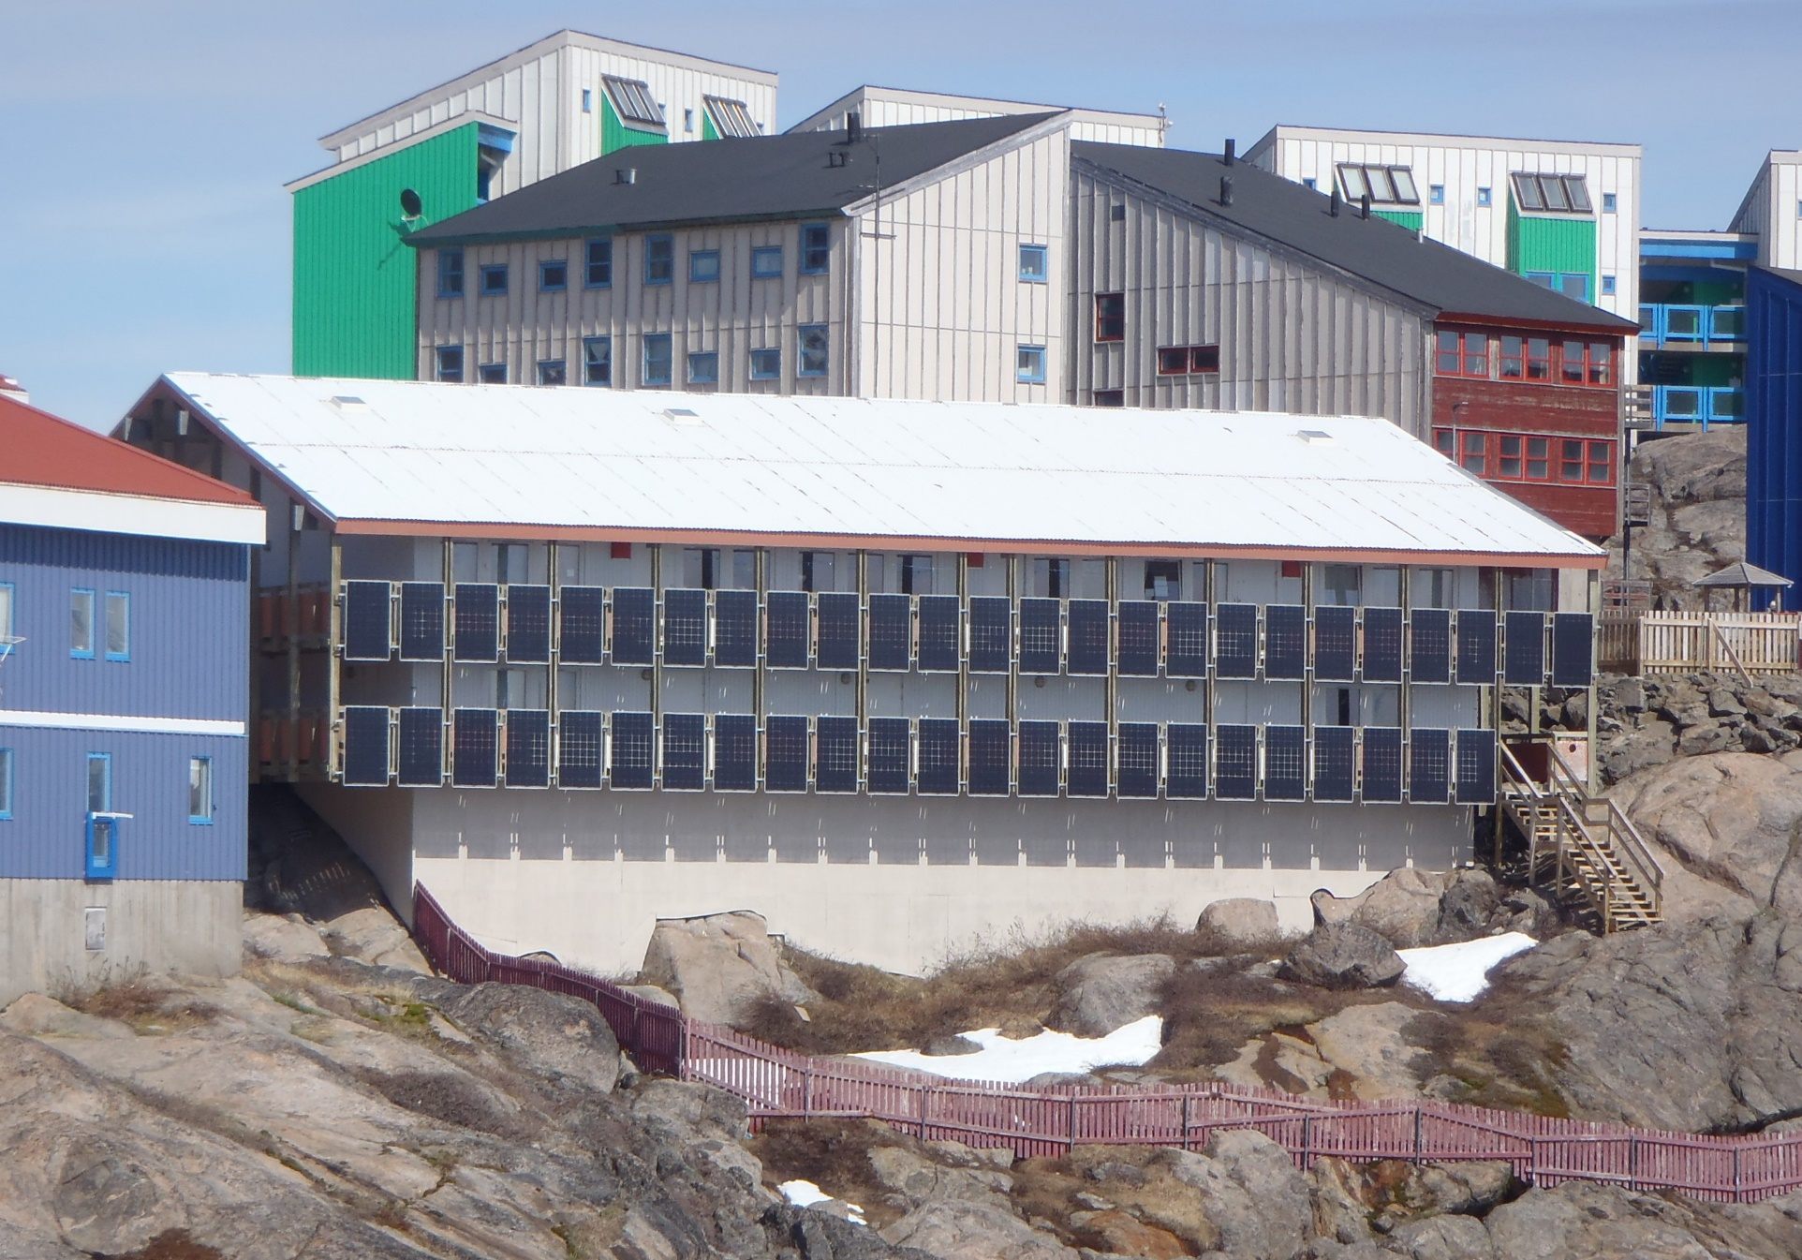
”Maniitsumi ukiuni kingullerni soorlu seqinisaatinik atuinerup ineriartortinneqarnera nuannerpoq", Teknikkeqarnermut, Aatsitassanut Avatangiiisinullu ataatsimiititaliami siulittaasoq oqarpoq. ”Inuit namminerisaminnik illuutillit arlaqartut seqinaatinik ikkussinikuupput, kommunillu illuutaani anginerusunik arlalinni seqinisaatinik ikkussuinikkut, Qeqqata Kommunia ineriartornermut tassunga malinnaanikuuvoq", Maniitsumi kommunip allaffiani, atuarfimmi utoqqaallu illuanni seqinisaatinik ukiuni kingullerni ikkussuineq innersuussutigalugu gideon Lyberth oqarpoq. Kommunip atuilluartuunissamik takorluugaanut ilaatillugu, seqinisaatinik atuinermik nutaamik misileraasoqarpoq. Utoqqaat Illuanni Neriusaami qaqqajunamut seqinisaatinik ikkussuinikuuvugut, meeqqerivimmilu Paarsimi illup nutarterneqarnerani seqinisaatit tulluarsarniarsarisimavarput, Gideon Lyberth naggasiivoq.
Borgmester Malik Berthelsen, Maniitsumi ineriartornermut aamma naammagisimaarinnippoq. "Sisimiut assigalugu Maniitsumi erngup nukinga atorlugu avatangiisinut navianngitsumik siunissami pilersitsivineqarsinnaassasoq neriuutigaarput. Tamannali pitinnagu, seqerngup nukinga atorlugu nukissamik Maniitsup pilersorneqarsinnaaneranut innuttaasut kommunilu ataatsimoorlutik suliniuteqartut takullugit nuannerpoq", taamak oqarpoq. Seqinisaatinik suliniuteqarneq pillugu, atortulersuutinik tunniussisuusumik ikkussuisuusumillu LED Solar Greenland-imik kommunip, Nukissiorfiit aamma ARTEK akornanni pitsaasumik suleqatigiissimanermut qujassuteqassallunga uannut aamma pingaaruteqarpoq”, borgmesteri naggasiivoq.
”Qeqqata Kommunia’s vision is to show the way to sustainability in the Arctic in 20120. Qeqqata Kommunia defines sustainability as passing on a better society to the next generation.” (see https://www.qeqqata.gl/Emner/Om_kommunen/Baeredygtighedsprojekt?sc_lang=da)

Other inspiring ideas in the Arctic:

Who can present the biggest cucumber in the Arctic – and stop malnutrition, shortage of fresh vegetables, create jobs and generate a profit at the same time?

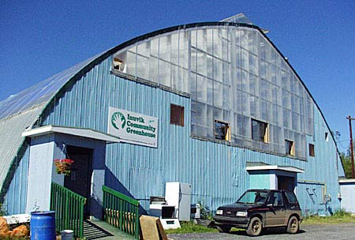

The Inuvik Community Greenhouse – see: https://inuvikgreenhouse.com/

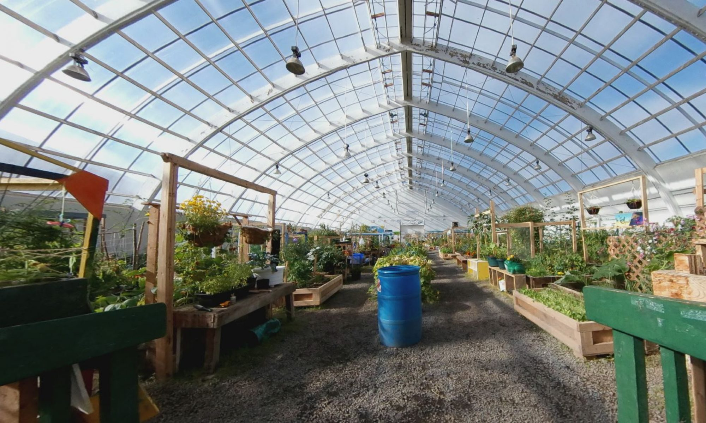

Containers for community sustainability:

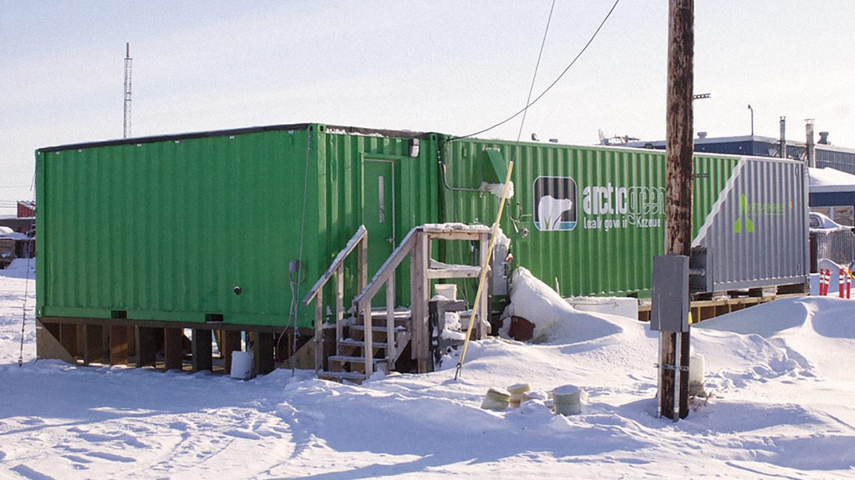

“A box of tricks that stops malnutrition, tackles food poverty, and creates jobs. A top end shipping container indoor farm can sell cheaper and better produce to Inuit villages than food flown in from urban centres in Canada.”
See http://www.gatewaycontainersales.com.au/shipping-container-farms-in-the-arctic/

Recommended reading list:

5.3.
Bastien, S. & Holmarsdottir, H. B. (2017). The Sustainable Development Goals and the role of youth-driven innovations for social change. In Bastien, S. & Holmarsdottir, H.B. (Eds.). (2017). Youth as Architects of Social Change: Global Efforts to Advance Youth-driven Innovation. New York: Palgrave Macmillan. Pp. 3-22.

6.3.
Text: Miles, M. P., Lewis, G. K., Hall-Phillips, A., Morrish, S. C., Gilmore, A., & Kasouf, C. J. (2016). The influence of entrepreneurial marketing processes and entrepreneurial self-efficacy on community vulnerability, risk, and resilience. Journal of Strategic Marketing, 24(1), 34-46

7.3.
Foley, D., & O'Connor, A. J. (2013). Social capital and the networking practices of indigenous entrepreneurs. Journal of Small Business Management, 51(2), 276-296.
Godoy, R., Reyes-García, V., Byron, E., Leonard, W. R., & Vadez, V. (2005). The effect of market economies on the well-being of indigenous peoples and on their use of renewable natural resources. Annual Review of Anthropology, 34, 121-138.

From the poem Tasama sermersuaq / crossing the ice cap. In: Tungujuaartumut by Kristian Olsen aaju, Atuagkat, Nuuk.

