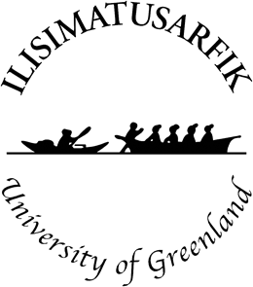

This is an Accepted Author Manuscript (AAM) of a research article published by SAGE Journals in Memory Studies on the 01 October 2021.

”Gendering Arctic Memory: Understanding the Legacy of Josephine Diebitsch-Peary”

Author: Silke Reeploeg, Associate Professor, Department of Cultural and Social History, Ilisimatusarfik, University of Greenland, Nuuk, Greenland.
Email: sire@uni.gl

Cite:
Reeploeg, S. (2021). Gendering arctic memory: Understanding the legacy of Josephine Diebitsch-Peary. Memory Studies, 14(5), 1061–1080. https://doi.org/10.1177/17506980211024327

This work is licensed under a Creative Commons Attribution-NonCommercial-NoDerivatives 4.0 International License, which permits non-commercial re-use, distribution, and reproduction in any medium, provided the original work is properly cited, and is not altered, transformed, or built upon in any way.

- Attribution — You must give appropriate credit, provide a link to the license, and indicate if changes were made. You may do so in any reasonable manner, but not in any way that suggests the licensor endorses you or your use.
- NonCommercial — You may not use the material for commercial purposes.
- NoDerivatives — If you remix, transform, or build upon the material, you may not distribute the modified material.

To view a copy of this license, visit http://creativecommons.org/licenses/by-nc-nd/4.0/.

Gendering Arctic Memory: Understanding the Legacy of Josephine Diebitsch-Peary

Abstract
The study of memory cultures often foregrounds the recovery of denied historical truths, with the recognition that social and cultural norms not only shape canonical versions of the past, but continue to be complicit in legitimised forms of forgetting and erasure. This article investigates the intersections between personal archives and other forms of cultural expression in acts of collective memoralization and forgetting. Using the personal archives of Josephine Diebitsch-Peary, the research introduces the concept of coloniality to studying Arctic memory cultures by examining the role of gender in the context of Arctic exploration. The article concludes that an understanding of the coloniality of knowledge and its connections to epistemic violence is crucial to the study of memory and historical legacy in the Arctic.

Keywords
Arctic, Gender, History, Memory.

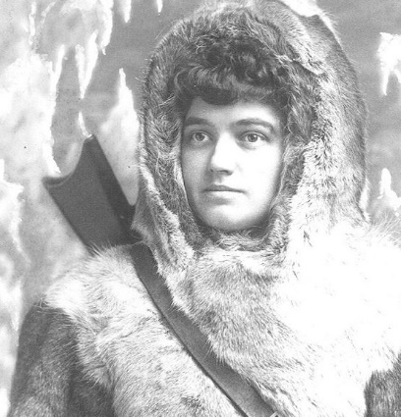
Fig. 1: Studio portrait of Josephine Diebitsch-Peary, wife of explorer Robert Peary. Published as a postcard in 1892 and later. E.S. Dunshee, photographer, 1330 Chestnut Street, Philadelphia, Pennsylvania, USA [Public domain]. Available at: https://upload.wikimedia.org/wikipedia/commons/7/7f/Josephine_Peary_portrait_1892.jpg (accessed 26 January 2020).

Arctic memory studies: coloniality on ice
In a recently published collection of articles on gender and memory in the European Journal of Womens Studies the editors emphasized the need for” new studies of gendering memory that employ multiple approaches and perspectives to tell new stories.” (Pető and Phoenix, 2019). Noting the many ways in which difficult collective pasts are remembered, they also suggested that the study of gendered memories lacks a focus on affect (Schwab, 2010) as an important factor in the transmission of traumatic, transgenerational memories. While a detailed study of affect goes beyond the primary purpose of this article, it is hoped that an Arctic perspective on this growing list of ’new stories’ will highlight gendered memory cultures as constituting difficult, necessarily affective, collective pasts that are associated with coloniality – the coloniality of memory (Reeploeg, 2019; López-Calvo, 2016). To do this, the article not only examines the role of colonial archives in the gendering of Arctic memory, but also the extent to which these memories constitute and transmit “the darker side of modernity” (Mignolo, 2011).
There has been a growing body of work that addresses colonial complicity and the need to actively engage in decolonizing practices in historical research (Vuorela 2009; Levine 2010; Mignolo and Walsh 2018). However, while colonial and post-colonial studies have occasionally investigated Arctic topics, little research has been done using the ideas and theories associated with coloniality (Körber, MacKenzie and Westerståhl Stenport 2017).
The notion of coloniality, a concept defined by Anibal Quijano and later developed by Walter Mignolo, provides a much needed lens through which to study memorialization, in particular when it comes to the coloniality of gender (Lugones, 2008). As a criticism of post-colonial studies’ inherently modern/imperial bias, coloniality introduces decolonial and anti-colonial options to Arctic memory studies. Coloniality refers to the hegemonic structures of power and control that emerged during the age of modernity and the associated periods of colonialism. Quijano (2007) makes an important distinction between colonialism and coloniality, with the first referring to Western imperial/colonial expansion, and closely linked with Christianity, the colonial conquest and colonization of the Americas, as well as the European expansion to Asia. Coloniality, on the other hand, is linked inherently to modernity, but also exposes the internal logic of different types of Western colonialisms and associated imperial projects. Mignolo argues that as coloniality is a necessary component of modernity, it cannot be ended or undone with the continuation of modernity, as suggested by many colonial and post-colonial scholars. These two positions, in fact, result in two very different modes of historical analysis (Migolo (2011).
While (post)colonialism, with its basis in postmodernism, refers to historically specific forms and periods of colonial domination, coloniality identifies the epistemic strategies and structures that underpin and continue the colonial project itself and carry it into the future. Coloniality therefore not only calls out visible form of colonial violence, but it also critiques Eurocentric epistemes or forms of knowledge production that Western civilization and modernity are based on. These continuously link the past, present and the future and are articulated through the colonial matrix of power (Mignolo 2011). Critically exploring coloniality can thus be said to question the framework of the conversation, as a first step towards leaving it altogether in favor of decoloniality.
Decolonial and anti-colonial scholars have long argued that the various processes of decolonization do not detach themselves from the modernity/coloniality conversation. Epistemic reconstitution has not taken place, leaving in place the overall structure of knowledge/dominant epistemes (systems of understanding). So, while (post)colonialism and decoloniality have the history of Western colonialism in common, their responses and aims are completely different. For example, while (post)colonial writers believe in the linear time of ‘before and after’ conceived by the European Enlightenment in the eighteenth century, decoloniality widens the historical framework to include a multitude of cultures and civilizations that have had Western epistemes (including conceptualizations of time) imposed onto them since the Renaissance in the fourteenth century. Significantly, and distinct from (post)colonial criticism, the unravelling of Western or Eurocentric thought is not abstracted from specific colonial systems, framed as an end in itself, or a path to reconciliation with the inevitable. Instead, the aim of decoloniality, as a methodological framework, is epistemic disobedience and reconstitution: the re-emergence and resurgence of erased knowledge, in/as praxis (Mignolo and Walsh 2018).
Using photographs, manuscripts and artifacts deposited at the Maine Women Writers Collection at the University of New England, Portland, Maine, US, this study focuses on the gendered memorialisation practices that surround the legacy of Josephine Diebitsch-Peary, wife of the polar explorer Robert Peary. In this the research adds to previous scholarship about archival sources by women as part of expeditions and travel literature in the Arctic in the late nineteenth and early twentieth century (Hansson, 2009; Herbert, 2012; McKenzie et al., 2012). However, understanding how memory is gendered in the context of Arctic exploration also entails a recognition of the entangled nature of collective memory (as represented by publications, archives and museums), with the coloniality of cultural memory (Jacobsen et al., 2013; Assmann and Assmann, 2011; Vuorela, 2009). In turn, recognising the connections between gender and the concept of coloniality is vital to understanding how archival collections shape Arctic memory cultures.
Archives, in their function of embodying and mediating modernity, act as part of coloniality (Assmann and Assmann, 2011; López-Calvo, 2016). Archives are never just static repositories of the past, but spaces where historical sources can be reactivated “to suit new governing strategies” (Stoler, 2009) or changing imperial systems (Joyce 1999). They are, in the words of archivists themselves, the “necessary monsters” (Yakel, 2000: 89) in the creation and transmission of collective memory. Rather than static depositories, archives produce memory by enacting colonial repertoires of memorialization. As such, colonial archives provide a register of imperial governance as well as contested and contesting epistemologies that constitute colonial power (Stoler 2009). In other words, archives are “spaces of memory” (Jacobsen et al., 2013: 222) where evidence to support historical narratives can be located that contrasts dominant historiographies and discourses, but only within the boundaries of the colonial matrix of power (Mignolo 2011). Any contradictions between collective and personal memories are then negotiated through multiple, but predetermined, processes that shape the circulation of both national and transnational memory and memoralization (Rigney and De Cesari, 2014).
Investigating the public and personal strategies adopted by women within a specific historical context illuminates the entangled nature of modernity/coloniality, not only with gender, class and race, but more widely, with the production of knowledge itself. Anti- and decolonial scholars have long integrated this understanding in order to find alternatives to re-entrenching and replicating Western gender discourses and practice (Andersen et al., 2015). (Post)colonial research, on the other hand, can be said to amplify colonial epistemes by seeking to normalise colonial encounters as part of a European cultural memory that aims for the continuation of modernity/coloniality - liberation from the centre (Kurtz, 2007; Vuorela, 2009; Andersen et al., 2015).
(…) even the circulation and repetitive application of the term post(-)colonialism is part of a (post-)colonialist discourse applied at the expense of the former colonized, who are struggling to find their place in the globalized world – freed from the straightjacket of post-colonial discourse with all its connotations and layers of hegemony and misunderstood good intensions. (Pedersen, 2014: 283-311, original spelling)
Accepting the ‘post-colonial condition’, as Birgit Pedersen points out, implies acceptance of and complicity with the coloniality of knowledge, including submitting to the hegemonic dominance of Western cultural memory (Assmann and Assmann, 2011; López-Calvo, 2016). As many indigenous, anti- and decolonial scholars have noted, this approach rarely unthinks and contests, but simply encourages a haunted and depressed “writing back from the Centre” (Pedersen, 2014: 305) and the continuation of the modernity/coloniality dynamic.
Scholars have long studied the creation and transmission of historical knowledge and discourses about the North (David, 2000; Stadius, 2005; Kaplan and McCracken Peck, 2013; Fjågesund, 2014). Arctic expeditions, particularly those led by Robert Peary and others trained in the military or Naval traditions, produced a homogenised, “hypermasculine region” (Lewander, 2009: 91) with a scientific and colonial history that created solid patterns of homosocial environments (Lyle, 2001: 126). As a transnational region, the Arctic therefore remains a cultural-historical space (Stuhl, 2016; Körber et al., 2017; Reeploeg, 2019) where “exaggerated models of masculinity prevalent in Anglo-American societies” are performed (Lyle, 2001: 125). The historical peak for this “culture of polar masculinity” (Lyle, 2001: 125-126) runs parallel to the ‘heroic’ age of Arctic exploration from 1818 onwards. In turn, Arctic memoralization narratives and discourses demonstrate how Edward Said’s orientalising techniques of the prejudiced but powerful Western outsider can be adapted and transposed onto ‘special areas’ in the world. This perspective produces a potent mixture of responses and attitudes towards the Arctic, often combining nostalgia with paternalism towards the peripheral, liminal, yet-to-be-fully-conquered- and known ‘North’ (Stadius 2001, Barraclough, Cudmore, and Donecker 2013).

Gendering exploration memories: ‘The remarkable women behind the World’s most daring explorers’
Although rarely remembered as part of Arctic history, or expedition histories in general, women have long participated in the construction of the idea of an exotic, Arctic region - usually via the genres of travel writing and autobiography, especially during the late nineteenth and early part of the twentieth century (Bloom, 1993; Lewander, 2009; Hansson, 2009). Lisbet Lewander notes that in the period 1867-1939 at least 500 European women visited Canada’s Northwest Territories, relating themselves to ”schools, missionary stations and medical facilities but also to commercial entities such as the Hudson Bay Company.” (Lewander, 2009: 90). Women were also ”tolerated as long as they were the wife of the captain or, later on, of an official in charge (…).” (Lewander, 2009: 91). Significantly, women provided a way in which remote areas could be considered part of colonial domesticity or sphere of control. It links to ideas about ‘mother nature’ aid the domestication of wilderness, but also implies that both women and nature should be subjugated to man/patriarchal ideas and practices (Bloom, 1993; McClintock, 1995; Romero Ruiz and Castro Borrego, 2011). Within existing historiographical writing, women therefore often appear as “providers of civilisation’s benefits” (Lewander, 2009: 93) in the Far North, which meant ’serving’ in the growing network of colonial institutions. However, while their publications aided the establishment of exotic peripheries where masculine Arctic adventure could be performed, the appearance of European women in the Arctic was also met with conflicting views about their role in the Far North (Hansson and Norberg, 2009). Travel accounts by or about women therefore “need to be read in the context of the gender anxieties at the end of the nineteenth century” (Hansson, 2009: 107).
Unlike other “Polar Wifes” (Herbert, 2012: 211), Josephine Diebitsch-Peary’s role oscillated between wanting to be seen as being a competent Arctic explorer herself, but also not wanting to transgress dominant gender norms and expressions of femininity. Her public image depicted this duality, and her own agency in choosing to dress in both masculine and feminine costumes.
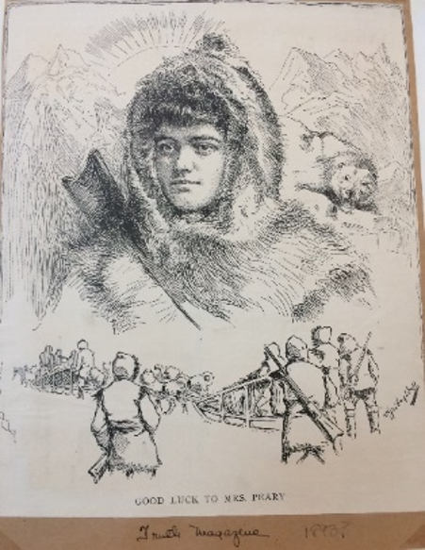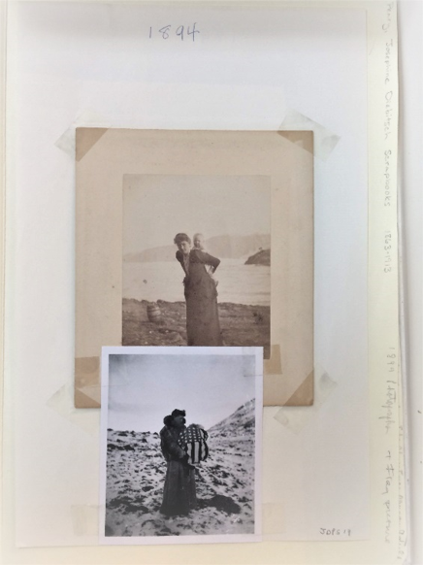
Fig. 2: “Good Luck to Mrs Peary” (1893?), Fig. 3: Josephine Diebitsch-Peary Scrapbooks JDPS 18, 1894. Maine Women Writers Collection, University of New England, Portland, Maine, United States. Photographs by the author.

While studio portraits have her wearing Arctic expedition clothing and a gun (Figs. 1 and 2), photographs taken by her husband during the expedition show her in a European-style fur coat, performing an idealized version of colonial femininity. Having given birth in Northern Greenland during their second expedition, the photographs show her holding her baby daughter, and imitating the Inuit method of carrying your child on your back (Fig. 3). However, over time, the more complex and ambivalent aspects of her public persona were reframed, with her identity as an Arctic explorer forgotten. While both images were widely circulated in the press at the time (Hansson, 2009) only the latter, depicting Josephine Diebitsch-Peary holding her baby daughter, wrapped in an American flag, is used in Robert Peary’s Northward Over the ‘Great Ice’ (Peary, 1914 (1898): 75, "The baby's first outing"). Today, Josephine Diebtisch Peary’s memory and, ultimately, her legacy as a historical figure, seems quite limited, remaining primarily attached to her husband’s value as one of the national heroes of American polar exploration. So, for example, the Macmillan-Peary Arctic Museum at Bowdoin College, Brunswick, Maine, US, displays a photograph of Josephine Diebitsch-Peary and her adult daughter holding an American flag, with no visual clues that both actually took part in the expeditions themselves.
Gendered memorialization practices, both inside and outside the archive, clearly form part of the creation and transmission of Arctic memory cultures (Reeploeg, 2019). Josephine Diebitsch-Peary’s legacy therefore represents one of many examples of the difficult collective pasts associated with Arctic memory cultures, as her removal also erases any references to the highly gendered, racial and sexual aspects of Arctic exploration itself. Then, as now, the Arctic acts as “proving ground to demonstrate manliness” (Lyle, 2001: 125). By extension, womens’ strategies for constructing possible identities and memory cultures within this context depend on transnational, social and personal identities established from the public marking and marketing of the female body within the Western male imaginary (Romero Ruiz and Castro Borrego, 2011; Rigney and De Cesari, 2014). So, while there is no doubt that “Women have been considered either absent from or powerless in the landscape of Arctic adventure” (Erikson, 2009: 104), this merely confirms how public memorialization practices are dominated by the existing epistemes and power structures of modernity/coloniality. In this context, archives embody both the ontological and epistemological possibilities and limits of archival practices (Stoler, 2002; Schwartz and Cook, 2002). So, for example, archives themselves are often separated out in special ‘Womens’ Collections’ that replicate existing social values and hierarchies (Erikson, 2009: 104; Levine, 2010). With the historical legacies of women so clearly gendered, it is worth examining more closely the complex nature of Arctic memory cultures and its relationship to modernity/coloniality (Reeploeg, 2019).
Literature about Arctic exploration has been an important part of the discursive vocabulary through which communal memory about the North is reproduced. The act of collective memorialization has taken place in a variety of cultural expressions and discourses (Ryall et al., 2010). Arctic explorers already had a set of expectations about the place, even before they set foot onto the ice. They expected to encounter dangerous and exotic people and places, comparable to other ’uncivilised’ areas of the world. This desire was not always satisfied, with the American explorer Vilhjalmur Stefansson, expressing his disappointment at the lack of savagery encountered: ”The people we have seen so far are disappointingly sophisticated.” (Stefansson in Palsson, 2002: 73). Arctic discourses intersect with other discourses of imperialism, nationalism, modernity, race, and gender. So, for example, the notion of Arcticality, as ”both hostile and strange, ’howling, exotic wilderness’ and friendly ’semi-domestic space’” (Ryall et al., 2010: 75) is replicated in most writing about Arctic expeditions. Women, as part of the Arctic expedition, here become a trope for expressing the desireable, friendly, possibilities of the hostile or ’frigid’ Arctic space, their presence instigating a domestication or ”feminisation of the North” (Hansson, 2009).
The construction of fixed, binary gender roles intensified with modernity and associated anxieties about the role of women in modern/colonial societies (McClintock, 1995). At the same time as women such as Josephine Diebitsch-Peary became workers, outside the home, they were also increasingly able to travel and publish independently, creating and transmitting their own versions of imperial discourses (Pratt, 1992). Within the Anglo-European context, these publications can thus be ”directly related to a general feminisation of travel literature in the second half of the nineteenth century that coincided with both an increased interest in the woman question and with the heightened emphasis on propriety and family values associated with the Victorian period.” (Hansson, 2009: 108). Victorian men and women were expected to ‘perform’ to defined ‘ideals’ that constructed specific social and cultural settings and behaviours (Porter, 2014 (1990)). Whereas masculinity was to be expressed in the arena of public or national interests, femininity should ideally be performed in the domestic or private arena of the family unit, a move that was also transposed onto the non-European cultures encountered in the Arctic (Arnfred and Bransholm Pedersen, 2015). However, the unfamiliar peoples and cultures encountered during expedition travel also gave rise to a rich and complex repertoire of biographical and fictional works that both invest in and subvert inherited European cultural discourses on gender and race (Mills, 1993). Dennis Porter interprets these literary ‘moves’ by authors as a transgressive activity animated by desire, but also haunted by different forms of guilt – the haunted journey North (Porter, 2014 (1990)). Visual examples of these extreme, often deliberately exaggerated, gendered practices can be seen in publications such as My Arctic Journal (Diebitsch Peary, 1894), and the cover page Le Petit Journal (1909).
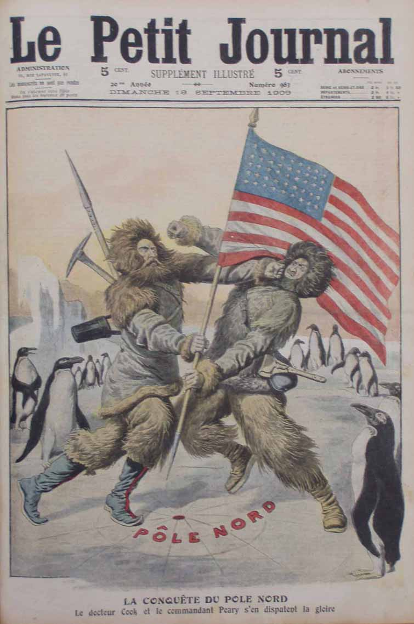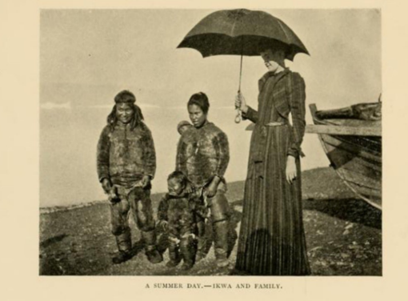
Fig. 4: “La Conquete du Pole Nord, Le docteur Cook et le commandant Peary s'en disputent la gloire” (The fight between Peary and Cook about the discovery of the North Pole, my translation). Le Petit Journal, 19 September 1909, 983.
Fig. 5: “A Summer Day – Ikwa and Family.” (Diebitsch Peary, 1894: 45).

Figure 4 depicts a physical fight between the two American polar explorers Peary and Cook over who reached the North Pole first (in the French daily newspaper ‘Le Petit Journal’). The cover draws attention to the exaggerated masculinity associated with polar exploration. This stands in sharp contrast with the second image (Fig. 5), a photograph from My Arctic Journal (Diebitsch Peary, 1894: 45). It shows Josephine Diebitsch-Peary in the company of an Inughuit family, on one of her expeditions to northern Greenland. As well as wearing European-style, ‘feminine’ attire (a tailored dress), she also sports a highly symbolic urban/colonial accessory – the umbrella.
The contrast between these visual forms of memoralization shows the separate gendered cultural spheres which these two personas (the explorer and the explorer’s wife) inhabit. Peary and his adversary fight it out in public - on the cover of a magazine. They are depicted in an empty space, standing on a highly symbolic map of the geographical territory of the Pole Nord/North Pole, surrounded only by ice and penguins (added for satiric emphasis here). The drawing illustrates the (even by contemporary standards) pointlessness of the fight, with the adversaries fighting under the same national flag. Josephine Diebitsch-Peary, the explorer’s wife, on the other hand, is shown in a very different context and environment. Published as part of a combined publication by the Peary couple, the title of the photograph “A Summer Day – Ikwa and family” (Fig.5) instantly domesticates this scene, as a friendly family ‘visit’ or excursion (not a heroic expedition). However, Josephine Diebitsch-Peary towers over the family, wearing a European dress – and her white skin (which must seemingly be protected from the Arctic sun with an umbrella). Ikwa and family are placed a few steps behind her, embodying both exotic contrast and racial difference. There is no eye contact between the people in the photograph. The Inughuit family seems focused on something in the distance beyond the photographer, with the tall, white woman looking down, into middle distance. As part of the discursive strategies of modernity/coloniality, this visual memoralization links to the haunted style of various other photographs taken by Robert Peary during his expedition, with their often visibily staged, paternalistic, but also uncanny performances of colonial visions of gender.
Northern coloniality: sex, lies and gendered memories in the colonial archive
Sara Ahmed (2007) has analyzed the way in which encounters with indigenous people not only produced desire and celebration, but also harm and fear, based on colonial visions of race, gender and sexuality. The bodies of indigenous women are both celebrated as colonial possessions, but also perceived as a threat to normative whiteness, and the ideal feminine form produced by Anglo-European culture (Ahmed, 2007). Ahmed notes the powerful emotions produced through complex formations of race, gender and sexuality (Ahmed, 2004), a perspective that is particularly relevant to encounters taking place as part of expeditions. Robert Peary’s Arctic expeditions, for example, used indigenous families not only as means of survival, but also normalized sexual relationships with Inughuit women, considering them essential to ”the retention of the top notch of manhood” (Dick, 2001: 382-383; Pálsson, 2004). As an expression of the patriarchal character of the culture of polar masculinity, this created an expectation of sexual availability in relation to the indigenous female body, including the right to sexually assault them when unwilling (Bloom, 1993: 126; Lyle, 2001: 382-384). When it comes to the relationships between Western women and their indigenous counterparts, it is interesting to note the nuanced nature of their encounters, with both hostile and sympathetic, but also paternalistic, attitudes being expressed. So, for example, the ambivalent racism that Josephine Diebitsch-Peary shows towards the indigenous women she encounters fluctuates between appreciation and disgust. There is gratitude towards Mrs Cross (the Inuk that helps her during the birth of her daughter, see diary excerpt on page 20), but also repugnance towards her husband’s indigenous partner, Aleqasina, as documented in private correspondence in 1909:

During these hungry years, I have been consoling myself ... with the thought that it was just as hard for you, & I must be brave for your sake ... On reaching Etah I find you have probably never given me a thought & a creature scarcely human has the power to make you forget everything except her. Oh my love, why do I live? (in Herbert, 2012: 211)
The visible despair at having an indigenous woman as the focus of her husband’s affection exposes the complex entanglements between race, gender and coloniality, with Josephine Diebitsch-Peary interpreting her husband’s actions as an attack on her own, thought racially superior, femininity. In fact, Josephine Diebitsch-Peary’s reaction to her husband’s relationship with the young, but also already married, Aleqasina, may explain why there is still today a total absence of any mention of indigenous family legacies in the public memory practices around Arctic exploration in general.
The existence of Peary’s two Greenlandic sons, Anaukaq (1900-1927) and Kali/Kale (born in 1906), has been a well documented fact and a matter of official record. Descendants on both sides of the family have long been aware of the connection, with family reunions taking place both in Greenland and the U.S. in 1987, and both Greenlandic and international researchers regularly referring to the extended Peary family (Vebæk, 1990: 85; Counter, 1991 (2002, 2018); Peary, 2019). It is beyond the scope of this article to survey the wider extent of indigenous oral and written histories about this aspect of the Peary legacy. Instead, prominence is given to existing work by indigenous scholars and cultural practitioners, who have already integrated their personal memories into collective, public memoralization praxis. So, for example, the Inughuit knowledge keeper, author and performer (Robert Peary’s direct descendant) Hivshu Peary II has long recorded and published his own praxis of decoloniality, noting that ”our colonized mind has to be freed from the distraction (Peary, H. 2020)”. The documentary The Prize of the Pole (Julén, 2006) explored the ways in which Hivshu Peary has been coming to terms with the Peary family legacy and the trauma that has been associated with it across generations.
Pia Arke, a Greenlandic-Danish artist whose practice was directly influenced by the visual archive of Peary’s photographic collections has pointed out what happened to cultural memory during and after this initial period of Arctic exploration. Memory is produced, but immediately “moved away and dispersed itself in picture archives, scientific studies, diaries, photo albums, attics and basement rooms in Denmark, Paris, New York, Oslo and Stockholm!” (Arke (1977) in Jonsson, 2016: np). Arke’s art and research focused on the colonial nature of public memorialization of indigenous bodies through these archival images, as well as providing a detailed critical analysis of the problematic function of “ethno-aesthetics” in western civilization (Arke, 2010 and 2012). The main theme of Pia Arke’s work Arctic Hysteria IV, 1997, for example, is a large montage of juxtaposed photographs appropriated from Robert Peary’s Northward over the ‘Great Ice’ (1898).
Meanwhile, the discursive vocabulary of Arctic memorialization continues to be shaped by dominant types of forgetting and/or erasing vital parts of Arctic history (Connerton 2008). In a book review about recent publications on Peary and other polar explorers Murielle Nagy (2008) notes the various strategies of silencing, misdirection and erasure of indigenous women in Arctic expeditions. Nagy points out that current scholarship is either completely ignored or sidelined by what are otherwise respected editors and authors in the field.
The weakness of this new edition of the 1934 book is the absence of annotations
from the literature that has since been published about Peary’s expeditions, that would have provided useful context. (…) Despite mentions of Bloom (1993), Counter (1991) and Henderson (2005), this edition too is silent about both Peary and his assistant Matthew Henson having relationships with Inughuit women and fathering children, facts well known to their Inughuit descendants and included in earlier publications (Nagy, 2008: 171).
Strategic acts forgetting, as well as ”epistemologies of ignorance” (Spivak 1999:2) are largely responsible for these erasures. Arctic memoralization practices continue to elevate and reconfirm comforting, dominant perspectives on exploration narratives. This is done by imposing silence on stressful topics that may cause the feelings of guilt and anxiety in Western audiences that go with understanding your own complicity in colonial violence and epistemic erasure. Where Arke has remediated colonial images and practices in order to create a parallel archive that reconstitutes erased memories, publications such as those discussed by Nagy repeat and amplify the dominant colonial typology of forgetting. It is vital to understand the difference between these two ‘moves’ taking place in the discursive construction of Arctic cultural memory. Both the materiality and praxis of producing and reproducing archival memory engender epistemological tensions that need to be understood and acted upon.
Gendering coloniality: memory assemblages in the archive
Research into the history of colonial encounters has regularly noted the intersection between gender, race and sexuality (Mills, 1993; Pálsson, 2004). The concept of “coloniality of gender” (Lugones, 2008) captures the intersection between gender, race and colonial legacies in particular. Coloniality, in this context, refers to the way in which Christian and European gender norms were superimposed onto indigenous societies around the world during various colonization phases, as well as during the writing of subsequent historiographical and anthropological studies of colonized peoples (Keskinen et al., 2009; Arnfred and Bransholm Pedersen, 2015). A body of scholarly work has increasingly addressed the many ‘blind spots’ when it comes to understanding the Arctic’s colonial past (Keskinen et al., 2009; Vuorela, 2009; Priebe, 2017: 2; Mattson, 2014; Öhman and Wyld, 2014), with new research on Nordic colonialisms (Höglund and Burnett, 2019) providing opportunities to connect Arctic research in North America and Northern Europe. Still, the role of women as colonial agents in the North remains a topic often overlooked, even more so when addressed within existing paradigms of womens’ history studies (Mills, 1993). The diaries, letters and artefacts contained in the Josephine Diebitsch-Peary archive therefore provide not only a rare female perspective on memory cultures in Arctic expedition archives but, more importantly, illustrate the overlapping aspects of memory and coloniality that produce the archival repertoire itself.
Josephine Diebitsch-Peary’s papers and a variety of personal objects were deposited at the Maine Women Writers Collection, University of New England, Portland, Maine, United States, from the year of her death in 1955 until 2003 (Diebitsch Peary, 1955-2003). As became clear in conversations with the archivist, the collection was added to and consequently revised and ‘re-curated’, mainly by her daughter, Marie. Perhaps she also added a shotgun to the collection (Fig. 7), which does not appear listed as an artifact. The collection’s catalogue, in fact, attributes the shotgun to her husband Robert Peary (“a shotgun belonging to Admiral Peary”, Fig. 6).
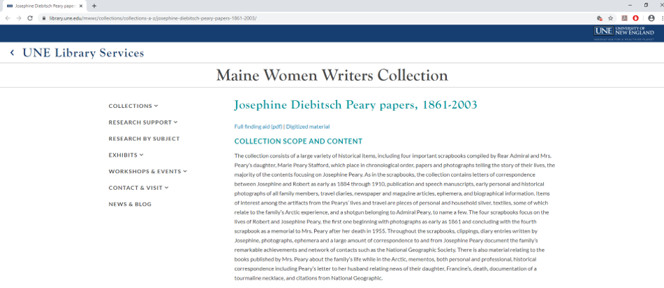
Fig. 6: Catalogue description, Josephine Diebitsch-Peary papers, 1861-2003, Maine Women Writers Collection, University of New England, Portland, Maine, United States. Available at: https://library.une.edu/mwwc/collections/collections-a-z/josephine-diebitsch-peary-papers-1861-2003/ (accessed on 10 January 2020).

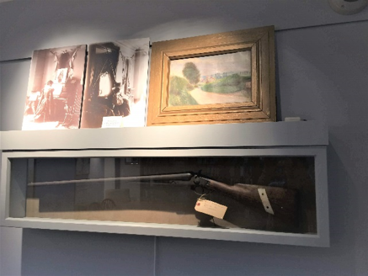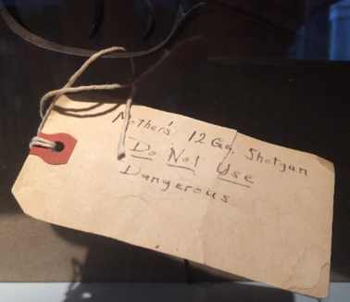
Fig. 7: Shotgun in display case. Fig. 8: Detail to Fig. 7, label on shotgun, “Mother’s 12 Gq. Shotgun, Do Not Use, Dangerous”. Maine Women Writers Collection reading room, University of New England, Portland, Maine, United States. Photographs by the author.

The shotgun is one of the larger artifacts displayed, and an unusual addition to the archive’s reading room. It is displayed in a glass case, alongside a number of framed studio photographs from inside the Peary residence on Eagle Island. The gun has a hand-written label with the inscription “Mother’s 12 Ga. Shotgun. Do not Use. Dangerous” (Fig. 8). The note demonstrates that the item was perhaps kept as a piece of memorabilia by the family, where this safety warning was necessary. No doubt it is the same gun that features, slung behind her back, in the studio portrait of Josephine Diebitsch-Peary used for postcards (Fig. 1), including a later drawing made for the cover of a magazine with the message “Good luck to Mrs Peary” (Fig. 4).
As can be seen from the memory assemblages that constitute this personal archive (documents, photographs, scrapbooks, artifacts) the public persona constructed here is complex. It shows a woman that knows how to use a shotgun, as well as a wife and mother who plays the piano in her well-furnished home. While photographs taken in summer during the actual expedition itself show her wearing European-style dresses and hats, Diebitsch-Peary also clearly enjoys performing her identity as an Arctic explorer, dressed in furs, with a shotgun across her shoulders. This ambiguity is repeated in her studio photography, which show her in various dresses, but surrounded by Arctic epherma at the Peary home (Fig. 6). The performance of quiet, domesticated femininity combines here effortlessly with presenting her as an adventurous polar explorer in her own right. While visual in form, it demonstrates the rhetorical repertoire of gendered heteronormativity (Ahmed, 2004).
Another way of examining these gendered memory assemblages is to pay attention to two objects contained in Josephine Diebitsch-Peary’s collection: the diary of her first expedition and a vanity set deposited at the archives (but not on display). Significantly, one important page – the day Josephine Diebitsch-Peary gave birth to her daughter, Marie Ahnighito Peary - seemed to be torn out of the original diary. It was then rediscovered on a separate page as part of her daughter Marie’s scrapbook project. This shows an interesting variant of the archival intervention practice of “remembering through remediation” (Bond et al., 2018: 221-241). Referring to the curatorial additions and interventions by visitors to a photographic exhibition, Frauke Wiegand describes how visitors openly leave written messages on the walls beside the photographs in the exhibition, including comments on both content of the photographs and personal memory associations. Marie Peary, although ostensibly a family member, rather than the general public, interacts with the materials in her mother’s archive in a similar way, by adding comments and her own memory associations. Lacking the public exhibition space afforded to her father’s memory (who shares an exhibition space in the Macmillan-Peary Arctic Museum), Marie Peary appropriates and reassembles her mother’s personal archive. Significantly, she rearranges the photographic and textual materials in scrapbooks – a private exhibition inside the archive itself.
As memory assemblages, scrapbooks are powerful artifacts, clearly authorized and integrated into modern memoralization praxis, in that they produce sanctioned “regimes of value” and embodied power (Christensen 2011). As a piece of memoralization technology, Marie Peary’s scrapbooks, together with numerous other archival ‘interventions’ by her daughter, show the multi-faceted ways in which a personal archive can enjoy a second and third life of remembering and forgetting. In this case, archival material is reshaped or ‘re-memorialized’ through repeated curatorial practices within the archive itself. So, for example, while Marie Peary curates the content of the scrapbooks, she also adds question marks, and comments. At the same time, the ‘new’ memory assemblages reafirm and repeat the gendered vocabulary of her mother’s memory. As a form of personal media assemblage, the scrapbooks also add value and context to the artifacts already deposited. So, for example, as well as adding her mother’s gun to the archive, Marie also deposited a silver-plated vanity set. The set consists of a hair iron, a tray, a mirror and a hairpin cushion and has never been displayed or been requested for research. Yet the gun and the vanity set have significant agency as memory objects and as part of the Peary rhetorical repertoire. Both were clearly deposited with a view to adding value to the understanding of Josephine Diebitsch-Peary’s legacy in her dual role - as a woman that could both hunts expertly and look after her hair.
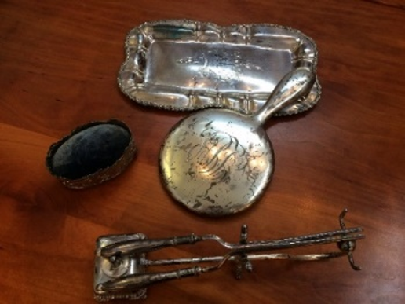
Fig. 9: Silver plated vanity set (mirror, tray, hairculing iron and pincushion) PJD 03.002-005. Maine Women Writers Collection, University of New England, Portland, Maine, United States. Photograph by the author.

The diary entry for what surely must have been a memorable day, when Josephine Diebitsch-Peary gave birth to her daughter in northern Greenland (Erikson 2013), is however of a very different nature. Noting this birth to be of public interest, it has again been remediated into a separate scrapbook by her daughter Marie. As this seems to be a deliberate curatorial intervention by the person being born that day – Marie – it shows unusual but not uncommon act in family commemoration practices by children recontextualizing childhood memory objects. As well as displaying this significant part of her own life, it seems the text on the page has also been amended. It reads
Woke up at 5am. Not feeling well, comfortable most of forenoon. Little girl born 6.35 pm. Weight 8.7 lbs. Large head + a long chin. Dr Vincent all that could be desired. Very kind + very attentive. Mrs Cross too was good to me. I am glad Mam did not see me but wish she was here now.”
(Diebitsch-Peary, J. 1893, Diary entry, JDPS 18) The detail of the weight of the child has been adjusted, as can be seen in Fig. 10).
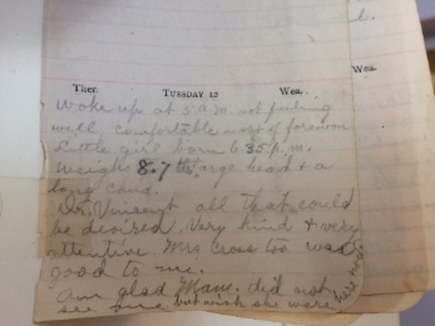
Fig. 10: Diary excerpt, Josephine Diebitsch-Peary Scrapbooks, JDPS 18, 1893. Maine Women Writers Collection, University of New England, Portland, Maine, United States. Photograph by the author.

It is impossible to know who made the apparent correction to the weight of the baby (see Fig.10), but clearly it seemed important (the writing is with emphasis). The description is remarkably short and matter of fact, considering an almost 12-hour period of labour (from 5am to 6.35pm). On the one hand this is considered (at least by Marie) an act of national significance (hence the physical remediation into her scrapbook exhibition). Yet, the language used by Josephine Diebitsch-Peary within the text is demonstratively neutral in tone. She emphasises the sex, weight and shape of the child, rather than the condition of the mother. This is Diebitsch-Peary’s way of using (lack of) emotion to convert the act of giving birth in the Arctic from a domestic scene into a patriotic event (also shown by wrapping the baby in the American flag, see Fig.5). The entry indicates an acceptance of the subordinate and unspectacular nature of this event within the hypermasculine arena of Arctic exploration. The birth itself is clearly subsumed under the bigger mission, which is focused on her husband. Robert Peary’s published recollection for this day reads:
On September 12th, an interesting event occurred at Anniversary Lodge in the arrival of a little nine-pound stranger, Marie Ahnighito Peary. Both mother and little one, as the result of the Doctor’s care and Mrs. Cross’s skilled nursing, passed through the ordeal safely (Peary, 1914 (1898): 68).
Memory assemblages here produce an archive that both reaffirms and repeats the gendered vocabulary of Arctic exploration discourses. While engaging in internal adaptation and remediation, the final result is still one of repetition of, and complicity with, dominant discourses and practices.
Gendering Arctic memory: complicity and consequences
Stefan Jonsson notes that “any attempt to conceive of a new narrative of the post-colonial Arctic will fail if it does not also entail a new narrative of European history.” (Jonsson, 2016: 1). Noting the powerful legacies of colonial memories of the Arctic, Jonsson points out the importance of questioning the narrating subject in travel literature and scientific discourses about the Arctic. Josephine Diebitsch-Peary’s legacy illustrates the difficulty of even assuming that there is one such subject that is responsible for the narrating, or one homogenous memory that may be the result. As can be seen in the analysis above, multiple layers of narration and remediation construct the archive’s many physical and textual memory assemblages according to sanctioned repertoires of gender and race. Yet, the construction and transmission of cultural memory takes place according to changing colonial archetypes within various historical contexts. The legacy of Josephine Diebitsch-Peary therefore illustrates how the gendered and colonial aspects of memory converge. The archive is “not just a place in which documents from the past are preserved; it is also a place where the past is constructed and produced.” (Assmann and Assmann, 2011: 13).
This study of the archival legacy of Josephine Diebitsch-Peary has demonstrated that both personal and public archives clearly offer knowledge which moves people to feel and act (Kurtz, 2007: 89), but only within the boundaries of modernity/coloniality. As a result, Arctic memory cultures risk reproducing dominant worldviews and forms of knowing, including epistemic erasures. This article therefore urges critical thinkers and practitioners concerned with the study of memory cultures to be more circumspect when confronting claims about the ‘new’ stories that can be told using ‘hidden’ archives or adding previously ‘unheard’ voices. The risks in simply replicating and amplifying dominant Western representations of memory are significant, and ultimately complicit with other forms of colonial violence. Understanding the coloniality of knowledge and its connections to epistemic violence is crucial to the study of memory and historical legacy in the Arctic. Memory studies practitioners must therefore be mindful to seek methodologies that unthink and contest forms of colonial complicity. Decoloniality, as a methodological framework, offers these options, with scholars actively engaging in both epistemic disobedience and reconstitution, fostering the re-emergence and resurgence of erased knowledge, in/as praxis (Mignolo and Walsh 2018).

Acknowledgements
This paper was presented at the 3rd Memory Studies Association Conference, Complutense Universidad, Madrid, Spain, 26 June 2019. The author would like to thank the chair and participants of the panel “Gendering memories all the way from heroism to dispossession” for their valueable comments and suggestions. I am grateful to two anonymous reviewers for their constructive suggestions and proposed corrections that improved the article.

Declaration of conflicting interests
The author(s) declared that there is no conflict of interest with respect to the research, authorship and/or publication of this article.

Funding
Research for this article was carried out as part of a post-doctoral fellowship entitled “Women in the Arctic, 1818-2018” funded by the Centre for Regional Studies (now the Centre for Sustainable Societal Transformations), Karlstad University, Sweden.

ORCID iD
Silke Reeploeg 0000-0002-5434-6352

References
Ahmed S (2004) The Cultural Politics of Emotion, Edinburgh: Edinburgh University Press.
Ahmed S (2007) A phenomenology of whiteness. Feminist Theory 8: 149-168.
Andersen A, Hvenegård-Lassen K and Knobblock I (2015) Feminism in Post-colonial Nordic Spaces. NORA - Nordic Journal of Feminist and Gender Research 23: 239-245.
Arke P (2010) Ethno-Aesthetics/Etnoæstetik. Copenhagen: Søren Arke, Kunsttidskriftet ARK, Pia Arke Selskabet & Kuratorisk Aktion.
Arke P (2012) Tupilakosaurus: An Incomplete(able) Survey of Pia Arke's Artistic Work and Research. Copenhagen: Kuratorisk Aktion.
Arnfred S and Bransholm Pedersen K (2015) From Female Shamans to Danish Housewives: Colonial Constructions of Gender in Greenland, 1721 to ca. 1970. NORA - Nordic Journal of Feminist and Gender Research 23: 282-302.
Assmann A and Assmann PE (2011) Cultural Memory and Western Civilization: Functions, Media, Archives: Cambridge University Press.
Bloom L (1993) Gender on Ice: American Ideologies of Polar Expeditions, Minnesota: University of Minnesota Press.
Bond L, Craps S and Vermeulen P (2018) Memory Unbound, Tracing the Dynamics of Memory Studies. New York: Berghahn Books.
Christensen, DE (2011) “Look at Us Now!”: Scrapbooking, Regimes of Value, and the Risks of (Auto)Ethnography. The Journal of American Folklore 124, no. 493 (2011): 175-210. Accessed January 6, 2021. DOI:10.5406/jamerfolk.124.493.0175.
Connerton, P (2008) ‘Seven types of forgetting’, Memory Studies, 1(1), pp. 59–71. DOI: 10.1177/1750698007083889.
Counter AS (1991 (2002, 2018) North Pole Legacies. Montpelier. Vermont: Invisible Cities Press.
David RG (2000) The Arctic in the British Imagination, 1814–1914. Manchester: Manchester University Press.
Dick L (2001) Muskox Land: Ellesmere Island in the Age of Contact. Calgary: University of Calgary Press.
Diebitsch Peary J (1894) My Arctic Journal: A Year among Ice-fields and Eskimos. London: Longmans, Green and Co.
Diebitsch Peary J (1955-2003) Josephine Diebitsch Peary papers. Maine Women Writers Collection, University of New England, Portland, Maine, US. Available at: https://library.une.edu/mwwc/wp-content/uploads/sites/2/2019/08/JosephineDiebitschPearyPapers.pdf. (accessed 10 January 2020).
Erikson PP (2009) Josephine Diebitsch Peary (1863-1955). Arctic 62: 102-104.
Erikson PP (2013) Homemaking, Snowbabies, and the Search for the North Pole: Josephine Diebitsch-Peary and the Making of National History. In: Kaplan SA and McCracken Peck R (eds) North by Degree: New Perspectives on Arctic Exploration. Philadelphia: American Philosophical Society, 2013.
Fjågesund P (2014) The Dream of the North: A Cultural History to 1920. Amsterdam, New York: Rodophi B.V.
Hansson H (2009) Feminine Poles: Josephine Diebitsch-Peary's and Jennie Darlington's Polar Narratives. In: Hansson H and Norberg C (eds) Cold Matters: Cultural Perceptions of Snow, Ice and Cold. Umeå: Umeå University, pp.105-123.
Hansson H and Norberg C (2009) Cold matters: cultural perceptions of snow, ice and cold. Umeå: Umeå University and the Royal Skyttean Society.
Herbert K (2012) Polar Wifes: The Remarkable Women Behind the World's Most Daring Explorers. Vancouver: Greystone Books.
Höglund, J and Burnett, L (2019) Nordic Colonialisms. Scandinavian Studies, 91 (1-2).
Jacobsen T, Punzalan RL and Hedstrom M (2013) Invoking ‘‘collective memory’’: mapping the emergence of a concept in archival science. Archival Science, 13.
Jonsson S (2016) Where humanism finds its ends: lessons from Pia Arke and Katarina Pirak Sikku on the difficulty of narrating the Arctic. Studies in Travel Writing 20: 226-236.
Joyce P (1999) The politics of the liberal archive. History of the Human Sciences 12: 35-49.
Kaplan SA and McCracken Peck R (2013) North By Degree: New Perspectives on Arctic Exploration. Philadelphia: American Philosophical Society.
Keskinen S, Tuori S, Irni S, et al. (2009) Complying with colonialism: gender, race and ethnicity in the Nordic region. Farnham: Ashgate.
Körber L-A, MacKenzie S and Westerståhl Stenport A (2017) Arctic Environmental Modernities: From the Age of Polar Exploration to the Era of the Anthropocene. Basingstoke: Palgrave Macmillan.
Kurtz M (2007) A Post-colonial Archive? On the Paradox of Practice in a Northwest Alaska Project. Archivaria 61: 64-90.
Levine P (2010) Gendering Decolonization. Histoire@Politique 11: 1-15.
Lewander L (2009) Women and Civilisation on Ice. In: Hansson H and Norberg C (eds) Cold Matters: Cultural Perceptions of Snow, Ice and Cold. Umeå: Umeå University, pp. 89-104.
López-Calvo I (2016) “Coloniality is not over, it’s all over.” Interview with Dr. Walter Mignolo (Nov. 2014, Part II). TRANSMODERNITY: Journal of Peripheral Cultural Production of the Luso-Hispanic World 6: 1, pp. 175-184. Available at: https://escholarship.org/uc/item/1k41z3x1 (accessed 26 January 2020).
Lugones M (2008) The Coloniality of Gender. Worlds & Knowledges Otherwise 2 (Spring): 1-17.
Lyle D (2001) European Cultures in the High Arctic, 1818-1940. Muskox Land: Ellesmere Island in the Age of Contact. Calgary: University of Calgary Press, 115-147.
McClintock A (1995) Imperial leather: Race, gender, and sexuality in the colonial contest. New York: Routledge.
McKenzie P, Savory I, Le Blond A, et al. (2012) The Right Sort of Woman: Victorian Travel Writers and the Fitness of an Empire. Newcastle upon Tyne, UK: Cambridge Scholars Publishing.
Mattson G (2014) Nation-State Science: Lappology and Sweden's Ethnoracial Purity. Comparative Studies in Society and History 56: 320-350.
Mignolo W (2011) The Darker Side of Western Modernity: Global Futures, Decolonial Options. Durham & London: Duke University Press.
Mignolo W and Walsh CE (2018) On Decoloniality. Durham: Duke University Press.
Mills S (1993) Discourses of Difference: An Analysis of Women's Travel Writing and Colonialism. London and New York: Routledge.
Nagy M (2008) Sex, lies and northern explorations: Recent books on Peary, MacMillan, Stefansson, Wilkins and Flaherty. Etudes/Inuit/Studies 32: 169–185.
Öhman M-B and Wyld F (2014) Lands of Fire and Ice: From Hi-Story to History in the Lands of Fire and Ice – Our Stories and Embodiment as Indigenous in a Colonized Hemisphere. In: Castejon V, Cole A, Haag O, et al. (eds) Ngapartji Ngapartji / In turn, in turn: Ego-histoire, Europe and Indigenous Australia. Canberra, Australia: ANU Press, pp. 241-257.
Pálsson G (2002) Arcticality: Gender, Race, and Geography in the Writings of Vilhjalmur Stefansson. In: Bravo M and Sverker S (eds) Narrating the Arctic, A Cultural History of Nordic Scientific Practices. Canton, Mass.: Science History Publications, pp. 275-309.
Pálsson G (2004) Race and the intimate in Arctic exploration. Ethnos 69: 363-386.
Peary, K (1990 (2017)). Peary, Kali (1906-1998). The Library of Congress. Washington D.C.: United States Congress Legislative Information. Available at: http://id.loc.gov/authorities/names/n90675408.html (accessed 20 January 2020).
Peary RE (1914 (1898)) Northward over the ‘great ice’: a narrative of life and work along the shores and upon the interior ice-cap of northern Greenland in the years 1886 and 1891-1897 New York: Frederick A. Stokes Company.
Peary RE II (2019) Hivshu's Ancestors, Aleqasina. Available at: https://www.hivshu.net/aleqasina (accessed 10 January 2020).
Peary, H (2020) About me, hivshu. Available at: https://hivshu.com/biography.html (accessed 3 November 2020)
Pedersen KB (2014) Greenlandic Images and the Post-colonial: Is it such a Big Deal after all? In: Körber L-A and Volquardsen E (eds) The Post-colonial North Atlantic: Iceland, Greenland and the Faroe Islands. Berlin: Nordeuropa Institut, pp. 283-311.
Pető A and Phoenix A (2019) ‘Indelible stains’? Introduction to special issue on Gender and Memory. European Journal of Women's Studies 26: 237-243.
Porter D (2014 (1990)) Haunted Journeys: Desire and Transgression in European Travel Writing. Oxford: Princeton University Press.
Pratt ML (1992) Imperial Eyes: Travel Writing and Transculturation. London & New York: Routledge.
Priebe J (2017) Greenland's future: narratives of natural resource development in the 1900s until the 1960s. PhD Thesis, Umeå Universitet, Sweden. Available at: http://urn.kb.se/resolve?urn=urn:nbn:se:umu:diva-142073 (accessed 26 January 2020).
Quijano, A (2007) COLONIALITY AND MODERNITY/RATIONALITY, Cultural Studies, 21:2-3, 168-178, DOI: 10.1080/09502380601164353
Reeploeg S (2019) Women in the Arctic: Gendering Coloniality in Travel Narratives from the Far North, 1907-1930. Scandinavian Studies 91: 182-204.
Rigney A and De Cesari C (2014) Transnational Memory: Circulation, Articulation, Scales. Boston: De Gruyter.
Romero RM and Castro Borrego SP (2011) Cultural Migrations and Gendered Subjects: Colonial and Post-colonial Representations of the Female Body. Newcastle upon Tyne: Cambridge Scholars Publishing.
Ryall A, Schimaski J and Howlit Wærp H (2010) Arctic Discourses. Newcastle-Upon-Tyne: Cambridge Scholars Publishers.
Schwab G (2010) Haunting Legacies: Violent Histories and Transgenerational Trauma. New York: Columbia University Press.
Schwartz JM and Cook T (2002) Archives, Records, and Power: The Making of Modern Memory. Archival Science 2: 1-19.
Spivak, GC (1999) A critique of post-colonial reason: toward a history of the vanishing present. Cambridge, Mass.: Harvard University Press.
Stadius P (2005) The North in European Mental Mapping. The North Calotte, Perspectives on the Histories and Cultures of Northernmost Europe. Helsinki: University of Helsinki, 14-25.
Stoler AL (2002) Colonial Archives and the Arts of Governance. Archival Science 2: 87-109.
Stoler AL (2009) Along the Archival Grain: Epistemic Anxieties and Colonial Common Sense, Princeton and Oxford: Princeton University Press.
Stuhl A (2016) Unfreezing the Arctic: Science, Colonialism and the Transformation of Inuit Lands. Chicago and London: The University of Chicago Press.
The Prize of the Pole. (2006) [Online] Directed by Julén S. Denmark: First Hand Films [Viewed 22 March 2021] Available from Vimeo.
Vebæk M (1990) Navaranaaq og Andre: de Grønlandske Kvinders Historie. Aalborg: Gyldendal.
Vuorela U (2009) Colonial Complicity: the ‘ post-colonial’ in a Nordic Context. In: Keskinen S, Tuori S, Irni S, et al. (eds) Complying With Colonialism: Gender, Race and Ethnicity in the Nordic Region. Farnham: Ashgate, 19-33.
Yakel E (2000) Thinking inside and outside the boxes: Archival Reference Services at the Turn of the Century. Archivaria 49: 140-160.

Notes

She graduated from the Spencerian Business College in Washington D.C. in 1880 and worked as a clerk at the Smithsonian and the U.S. Department for the Interior (Erikson PP. (2009) Josephine Diebitsch Peary (1863-1955). Arctic 62: 102-104.).
Inughuit are North Greenlandic Inuit that form about 1% of the population of Greeland. The term Inuit refers to people more generally that inhabit the Arctic areas of Greenland, Canada and Alaska.
It also included a lengthy introduction by Robert Peary, and his own narrative entitled “The Great White Journey across Greenland”.
Peary, Kali (1906-1998). The Library of Congress. Washington D.C.: United States Congress Legislative Information.
See also Josephine Diebitsch-Peary Images, University of New England digital collection DUNE: DigitalUNE, Available at: https://dune.une.edu/jpeary_images/ (acccessed 10 January 2020). Author biography Silke Reeploeg is Associate Professor at Ilisimatusarfik, the University of Greenland. With a background in Area Studies, she is interested in the ways the Arctic region grapples with its past, present as well as future. She has published in several journals including Northern Scotland, Scandinavian Studies and Scandinavian Canadian Studies / Études Scandinaves au Canada, as well as contributed chapters to edited volumes on cultural studies, northern histories and coastal cultures. Her current research areas are Arctic memory/heritage cultures, micro-history and anti-/decolonial perspectives.

